1. You get a error that says, “Our apologies…”
   1. 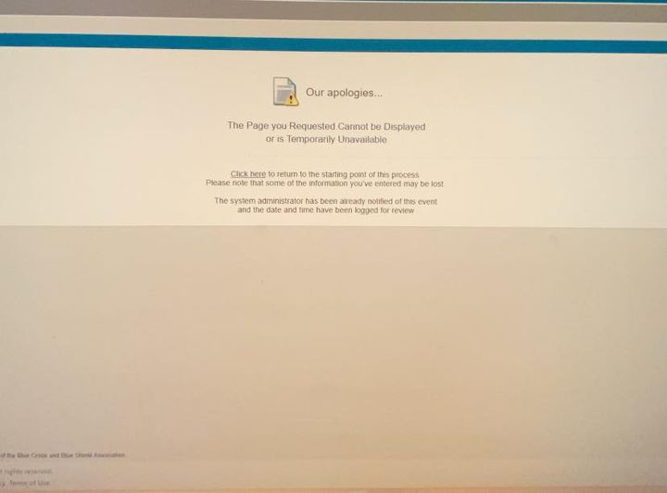When that happens, that is caused by your user profile within Carelon is incomplete.
   2. How to Fix
      1. Restart your request for Blue-E from the beginning (Health Management, enter the prefix & Diagnostic & Specialty Care)
      2. Click “I Agree” to get through the HIPAA disclaimer.
      3. A screenshot of a computer

         Description automatically generatedOn the main screen, click on the top right, **Manage Your User Profile**



* + 1. A blue and white sign

       Description automatically generatedInside your user profile, click on the **User Information** tab to review your information
    2. A screenshot of a computer

       Description automatically generatedEnter in all of the highlighted fields & then click “Save.” You should then be able to begin your preauthorization request.